
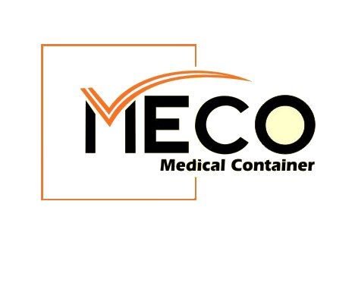Best Practice Guide for
Polypropylene Products in Sterile Services





Decontamination of medical devices is an issue of public health importance and a priority for hospital management and Sterile Services staff. The effective decontamination and sterilization of re-usable medical devices is essential in minimising the risk of transmission of infectious agents and Hospital Acquired Infections (HAIs). The risk of HAIs and other infections can be increased if blood residue and bacteria is not removed effectively from contaminated surgical instruments and medical devices.

The presence of blood residue and bacteria on a re-usable medical device can render the item non-sterile and unsafe for further use on patients, and become a handling risk to hospital staff.

Page 1

Why Use Polypropylene in Sterile Services?

Medical devices such as re-usable instrument trays, gallipots and kidney dishes are widely used

in Theatres, Sterile Services and Decontamination departments as instrument containers and receivers to form an effective part of the sterile field in surgical procedures. They are also used to contain and protect surgical instruments through the decontamination cycle, from Cleaning, Disinfection, Inspection, Packaging, Sterilization, Transport, Storage, and Use.

The Decontamination Cycle
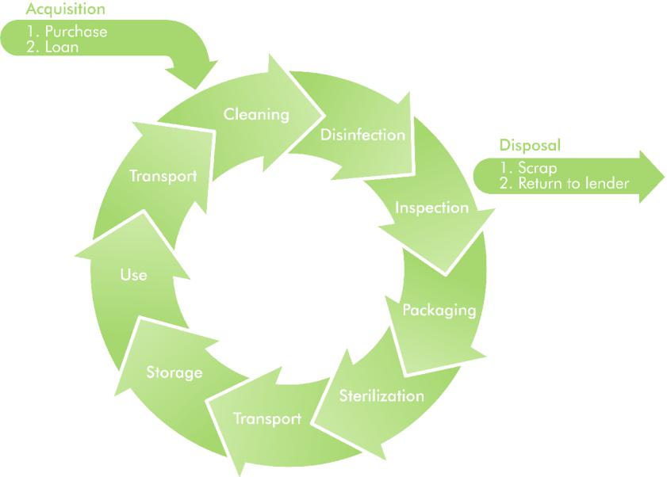

The establishment of a ‘sterile field’ in an operating room or surgery on and around the patient is vital in minimizing the risk of infection to the patient. There are specific aseptic techniques and processes that must be used to introduce supplementary equipment that is required during surgery, and these items must be removed from the surgical area in the same manner.
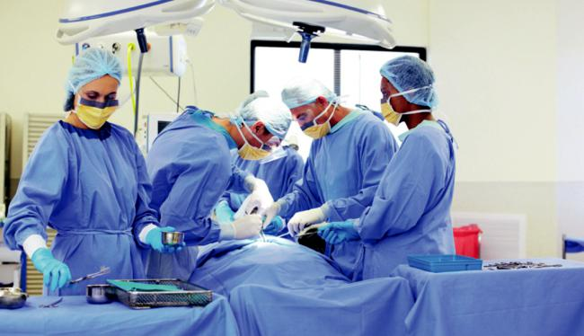

Surgical equipment, instruments, clamps, drills and other surgical accessories must be provided to the operating room or clinic prior to the surgical procedure commencing. During the procedure, these items will need to be passed to the surgical team and removed from within the sterile field in such a manner that the sterile field is not compromised.

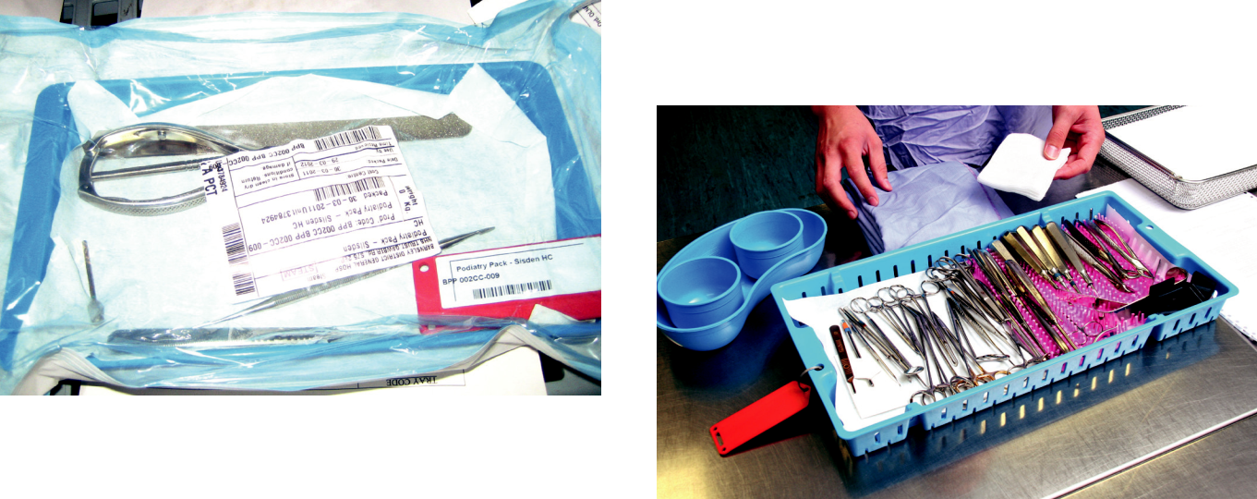

Such equipment will need to be prepared in trays and containers that are packaged within a sterile barrier wrap. These sterile barriers are made of a reusable fibre that meets the required standards of disposable paper and drapes. On opening this outer wrap, the Scrub Nurse will take the items contained within the inner wrap that forms a sterile barrier. This then also becomes part of the Sterile Field and must not be compromised.

Polypropylene re-usable medical devices are now favoured in hospitals and Sterile Services as a more durable, cost effective alternative to stainless steel products.

Page 2

How is Polypropylene used in Sterile Services?

Kidney Dishes
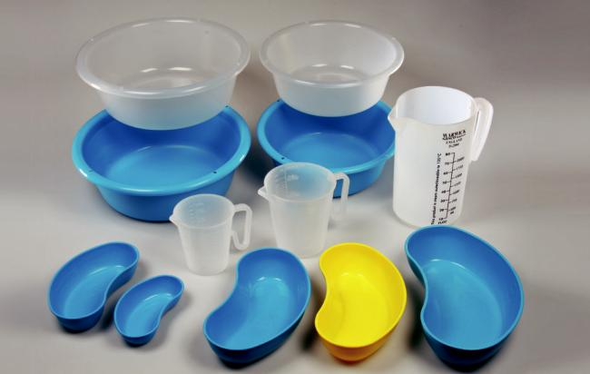

• Used to contain injection syringes, butterfly clips, shunts, cannula, swabs, sharps, etc.

• Passing surgical instruments and equipment to the Surgeon.

• Passing bone screws, bone plates, drill bits, saw blades.

• Containing vascular slings, bulldog clamps for tiny vessel surgery.

• Small neuro swabs, sutures, harvested grafts.

• Kidney dishes can be used as a temporary waste container to hold used equipment and remove it from the sterile field.
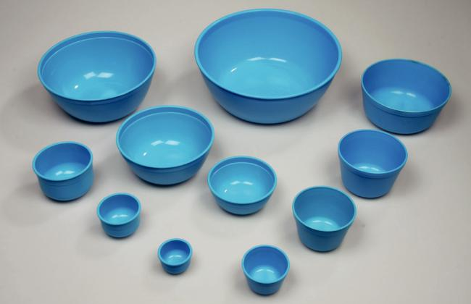

• Also used in hospital wards and surgery clinics for small procedure sets - instruments, swabs and sponges.

Gallipots

• Used to contain and dispense lotions and liquids for surgical preparation, skin/wound cleaning: Iodine, Betadine, Chlorhexadine, Hydrogen Peroxide, Matische Dyes etc.

• Also often used to retain harvested grafts.

Instrument Trays

• Used to contain the instruments and equipment necessary to complete the procedure. This may be a single tray or multiple trays for the same procedure.
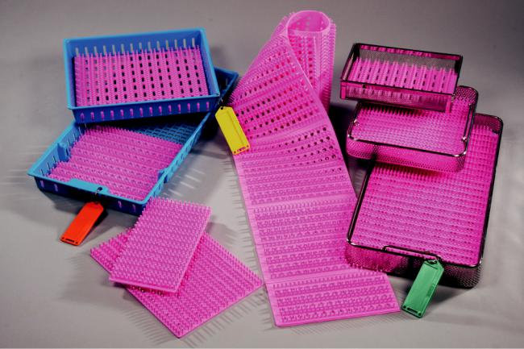

• A Scrub Nurse will regularly take supplementary instruments onto her tray that have been opened and passed from outside the sterile field if an instrument has been dropped and requires replacement or the Scrub Team require additional instruments such as probes, trocars, needles, forceps, spatulas and suction tubes etc.

Jugs

• Used for measuring fluids - both to and from the patient.

• Draining up fluids for multiple applications e.g. wound irrigation

All surgical instruments, equipment and accessories must be accounted for at the end of the procedure. Those items that are being returned to Sterile Services for reprocessing must be placed in a receiver then placed on the instrument tray. This enables the Nursing Team to complete their instrument check at the end of the procedure and also enables Sterile Services to check that correct used items have been returned for reprocessing ready for the next procedure.
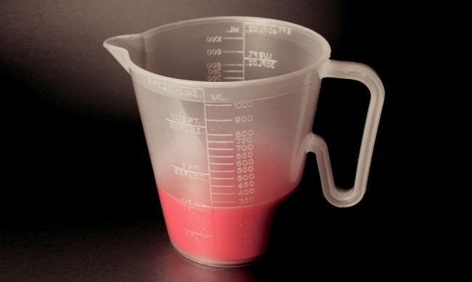

Page 3

Benefits of Polypropylene as an alternative to Stainless Steel

 | Disadvantages of Stainless Steel |  | Advantages of Polypropylene
Weight | Stainless steel medical devices are very heavy. Lifting heavy trays, |  | Polypropylene trays and devices are 50%
 | especially when loaded, may exceed safe manual handling limits. |  | lighter than stainless steel and so assist
 | The weight of packs must be taken into consideration when |  | operators with storage, lifting and handling
 |  |  | and reducing health and safety risk to the
 | assembling surgical trays.
 |  |  | operator.
 | Advisory Guideline* is 11.5kgs maximum weight for instruments,
 | including the packing system. Pack weight is 7kg for women and
 | 10kg for men.
Noise | Stainless steel is a very noisy and cold product to use. Processing |  | Polypropylene is a significantly quieter product
 | stainless steel trays and instruments can result in a very noisy work |  | to process, so busy SSD and Decontamination
 | environment for operators and staff. |  | Units will benefit from a quieter working
 |  |  | environment.
Colour | Stainless steel trays and containers can get damaged by |  | Polypropylene is very hard wearing and is
and | instruments and the sterilization process. Surface scratches to the |  | intended for repeat processing.
and | steel can lead to oxidisation (rusting), which affects the sterility of |  | meco products are guaranteed for a
Surface | the pack. |  | minimum of 500 wash cycles.
Finish | Stainless steel is easily corroded by the effect of chemicals, |  | Polypropylene cannot be affected by
 | particularly oxygen which causes oxidisation, commonly known |  | oxidisation (rusting) so any surface scratches
 | as rust. Over time stainless steel will corrode and get damaged, |  | will be harmless and will not affect processing
 | including pitting of the surface, loss of strength, degradation of |  | or sterility results.
 | appearance, breakage, and accumulation of chemical scale and |  | Polypropylene is also resistant to damage
 | rust. All of these factors will affect the sterility of the pack and
 |  |  | caused by other chemicals, cleaning solutions
 | instruments and can lead to adverse patient outcome. Scratched
 |  |  | and medicines.
 | and worn stainless steel devices should be discarded immediately.
Tray | Stainless steel bowls and trays are liable to buckle if dropped or |  | Polypropylene is difficult to break and is able
Damage | damaged, which can affect sterility and reduce the number of |  | to withstand the impact of 1.25m drop test.
Damage | instruments that can be fitted into a tray.
Wrapping | Sharp edges and wires of stainless steel can easily puncture |  | Polypropylene devices have smooth corners,
Wrapping | wrapping paper and pouches. This renders sets non-sterile and |  | edges and a surface finish that eliminates
Damage | needing to be re-processed, costing time and money. |  | paper rips. This reduces the need for
 | Stainless steel trays can become damaged over time, resulting in |  | re-processing, saving the Sterile Services
 |  |  | Department time and money, and extends the
 | wires sticking out with the potential risk of injury to operators and |  | shelf life of the sterile pack.
 | theatre staff. Damaged trays should be removed from use and |  | Polypropylene has no sharp edges or surfaces
 | replaced with new products immediately.
 |  |  | that can cause potential injury to operators or
 |  |  | theatre staff.
Cleaning | Stainless steel products must be cleaned thoroughly prior to |  | Polypropylene is not susceptible to rusting.
 | sterilization. There can be residual staining on the device surfaces |  | Polypropylene is compatible with all hospital
 | which can be caused by patient soil, iodine scrubs or rusting. Soil
 |  |  | cleaning detergents and is resistant to chemical
 | and iodine can be easily removed during cleaning but rusting will
 |  |  | damage.
 | not. A visual sign of rusting is often an indication that the device is
 | damaged. |  | Polypropylene delivers enhanced cleaning and
 | Even good quality stainless steel will rust with repeated use. |  | sterilisation results as blood protein does not
 |  |  | adhere to the surface of polypropylene and is
 | Excessive use of certain acid based cleaners will cause rusting,
 |  |  | easily removed from the device.
 | which will affect sterility of the pack.
 | Testing has also shown that blood protein adheres to stainless steel
 | surfaces and is difficult to remove - affecting the sterility of the
 | pack and possible patient outcome.
Heat | Stainless steel will absorb heat from the autoclave and cleaning |  | Polypropylene is heat passive and does not
Retention | machines, so devices unloaded can be very hot to handle. |  | retain heat. Therefore it can be handled easily
Retention | Protective equipment must be used to prevent operator burns. |  | and safely by operators, resulting in a speedier
 |  |  | unloading process.

Page 4

Why Choose Medinova Ind Products?

Medinova is a India based manufacturer of re-usable and single use polypropylene medical devices.

For over 30 years, Warwick MECO has enjoyed success in supplying plastic medical devices that meet the demanding requirements of healthcare processing. We are now recognised as the market leader in the design and manufacture of high quality medical polyware and our products have an unrivalled reputation for quality in over 65 countries around the world.

We have worked closely with the Department of Health, Sterilizing Associations and Infection Control Managers both in the UK and Overseas, to establish high quality standards, procedures, and products that consistently deliver correct sterilization results. These product specifications have become the standards used universally for the washing, decontamination, packing, and sterilization of surgical instruments and equipment in hospitals around the world.

We offer a wide range of long life re-usable and single use products that are widely used in Sterile Services, operating rooms, and clinics as a more durable, cost effective alternative to old and expensive stainless steel products.

- All products are certified to comply with ISO 9001 Quality

Management System and EU Medical Devices Directive, and we were one of the first healthcare companies to adopt the standard in 1997.

- Our polypropylene is compliant with ISO 10993

(Biocompatibility of medical devices) and the raw material is approved for use in medical devices. It is inert, non-combustible, non-toxic and non-carcinogenic. It is safe for use in medical and nursing applications and is resistant to damage from chemicals, cleaning solutions and medicines.

- Material colourings are safe, non-toxic and comply with

Directive 67/584/EEC on Dangerous Substances and Directive 67/769/EEC to protect human health, the environment and the interests of consumers.

- Polypropylene is identified as a Class 5 material, which can be recycled in accordance with regulations on clinical waste and hospital protocol.

- MECO products are classified as Class 1 Medical Devices under Council Directive 93/42 EEC and show the CE mark accordingly.

- MECO is certified to ISO 9001 (Quality Management System) and ISO 13485 (Medical Devices Quality Management).

- Polypropylene has a high temperature tolerance, making it ideal for use in autoclaves. The Warwick and SteriLite ranges are designed to be steam autoclaved in autoclaves compliant to HTM 2010, BS 3970, EN285 and ISO 17665, with a processing temperature of 134°C.

- Warwick and SteriLite products can also be processed by Ethylene Oxide and Gas Plasma, Electron Beam and Gamma
Ray. Refer to Sterilizing Processor for more information.

- Products have smooth corners and surfaces which eliminate paper rips, and rounded feet on trays, bowls, and kidney dishes keep the items clear of any spillages.

- Polypropylene has improved results in blood protein removal when compared to stainless steel.

- Gallipots, bowls and kidney dishes have a collar below the rim that strengthens the product and helps to maintain shape when autoclaved. The small pips on the rim help to prevent ‘vacuum lock’, enabling a clear passage for steam penetration and vacuum release.

- The shaped rim gives a sure grip when wearing latex gloves, and the smooth brim ensures no dripping or spilling when pouring liquids.

- Perforated and mesh base trays improve steam penetration and drainage, which helps eliminate wetness after autoclaving.

- Bowls and kidney dishes have graduated scales to act as a quick reference when measuring.

- All instrument trays include tag holes for securing traceability tags.

page 5

Product Processing and Technical Information

MECO Products |  | SteriLite Products
Material |  | Material

Products are manufactured from polypropylene plastic, unless where stated in product catalogue.

Products are manufactured from polypropylene plastic.

Processing

Decontaminate and wash in machines compliant with ISO 15883 and HTM 2010 (UK). Hand washing is permissible. Maximum washing temperature 90˚C. Sterilize in compliance with
ISO 17665, ISO 25424 and HTM 2010 (UK) in autoclaves compliant to BS EN285. Sterilization temperature 134.6 + 2˚C.

Compatible with Ethylene Oxide (ETO), Gas Plasma/Hydrogen Peroxide sterilization, Electron Beam (E Beam) and Gamma Irradiation.

Processing

The SteriLite Range is single use and should not be re-processed.

There are no instructions for re-processing.

Sterilize in compliance with ISO 17665, ISO 25424 and HTM 2010 (UK) in autoclaves compliant to BS EN285. Sterilization temperature 134.6 + 2˚C. Compatible with Ethylene Oxide (ETO), Gas Plasma/Hydrogen Peroxide sterilization, Electron Beam (E Beam) and Gamma Irradiation.

Validation

Products processed in accordance with ISO 17664 are validated for sterility after cleaning, disinfection and autoclaving. Further processing, validation, bio-burden, technical information,
and compliance to ISO 17664 evidence is available on request. Products are designed and manufactured to meet the requirements of BS 5452.

Validation

Products processed in accordance with ISO 17664 are validated for sterility after cleaning, disinfection and autoclaving. Further processing, validation, bio-burden, technical information, and compliance to ISO 17664 evidence is available on request.

Material Compliance

The polyproplene used at Medinova ind complies with EC Directive: 2002/72/EC and EC Regulation No: 1907/2006. Further information on material compliance is available on request.

Polypropylene is classified as a Class 5 Recyclable plastic material. Hospital waste products must be disposed of in accordance with regulations on clinical waste and hospital protocol. Polypropylene is suitable for incineration.


Certification

Medinova ind is certified to ISO 9001 and ISO 13485.

Products are classified as Class 1 Medical Devices under EC Directive 93/42 (CE Mark).

The Warwick Range complies with BS 5452 Standards for Hospital Hollow ware.

page 6

